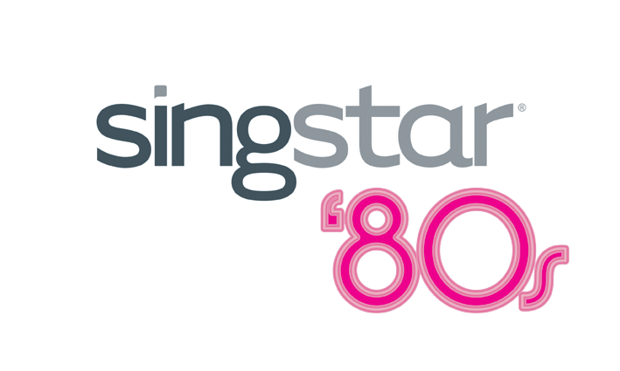

SingStar ’80s
- Don’t you just love the ’80s…

Culture Club. Blondie. Wham!
Hear the names and the songs just pop in to your head. Sony Computer Entertainment Europe (SCEE) is pleased to announce that, in response to lobbying from SingStar™ fans around the world, Studio London is developing the definitive nostalgic music experience – SingStar ‘80s. Brace yourself for the ultimate ‘80s invasion, available just in time to kick start your party season.

SingStar ‘80s features the first era-specific track listing to emerge from the music gurus at London Studio and comes packed with 30 original and totally classic tracks from the early ‘80s that are guaranteed to throw you back to your school disco days. Recreating the iconic style that defined the era, SingStar ‘80s brings the decade back to life with a new ‘80s-themed intro, retro colour scheme, fully licensed tracks from the original artists, and, of course, the videos that ushered in the dawn of music TV.

Providing pop kids with a great excuse to dig out the neon T-shirts, the frilly shirts or lace fingerless gloves, SingStar ‘80s fills your home with the tunes that topped the charts in Europe and around the world, from leading artists including The Cure, Kate Bush, Frankie Goes to Hollywood, Erasure and Simple Minds. Journey back in time and indulge in nostalgic classics such as:

  - Culture Club: Karma Chameleon
  - Vanilla Ice: Ice Ice Baby
  - Belinda Carlisle: Heaven is a Place on Earth
  - Simple Minds: Don’t You (Forget About Me)
  - Nena: 99 Red Balloons
  - Frankie Goes to Hollywood: Power of Love
  - Blondie: Atomic

  - Kate Bush: Running up that Hill
  - Foreigner: I want to know what love is
  - Europe: The Final Countdown
  - Soft Cell: Tainted Love
  - Wham!: Wake me up before you go, go!
  - Pretenders: Brass in pocket
  - Billy Joel: Uptown Girl
  - Erasure: A little respect
  - Starship: We built this city

Easy to set-up and play, SingStar ‘80s comes with two high quality microphones and tracks players pitch, tone and rhythm, as they sing into the mic. SingStar ‘80s has got what it takes to turn even the most tone deaf of singers into a ballad-wailing sensation, -- all you need to do is raid your wardrobe, put on your make-up, peroxide your hair, line up that power ballad and wow the crowd!

SingStar ‘80s will be released for PlayStation®2 across PAL Territories from 4 November 2005 and will feature tailor-made tracklists in Germany, France, Italy, Poland and Holland (some of the above artists may not therefore feature in your local version).

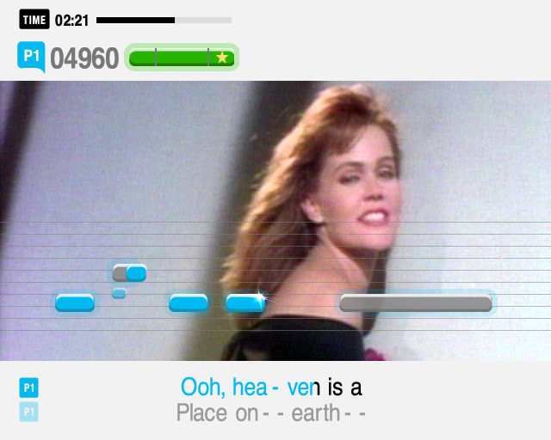
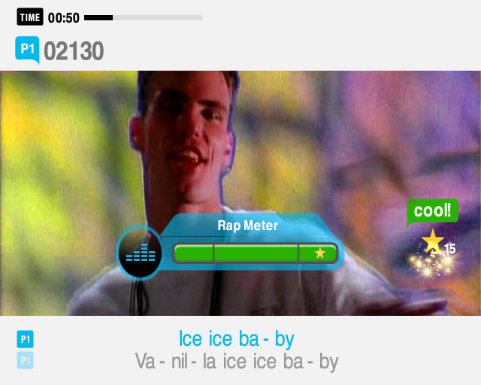
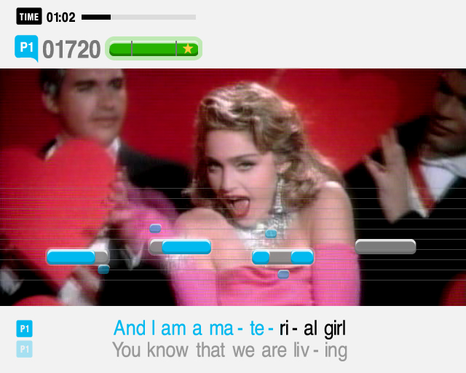
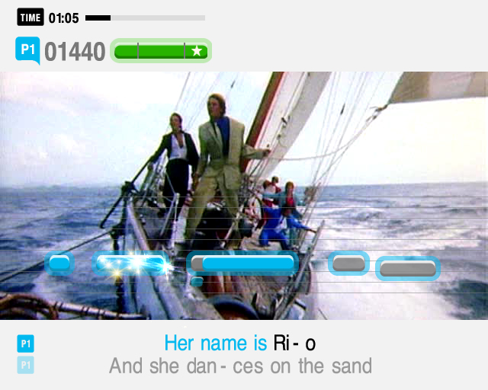

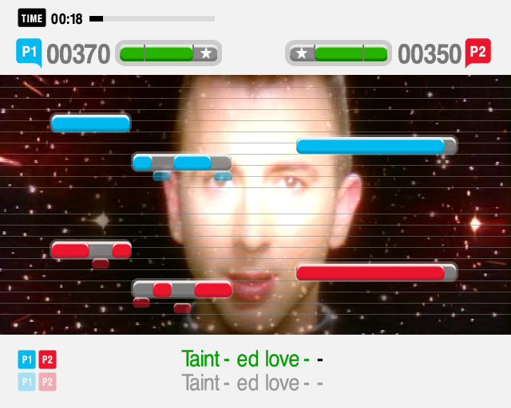
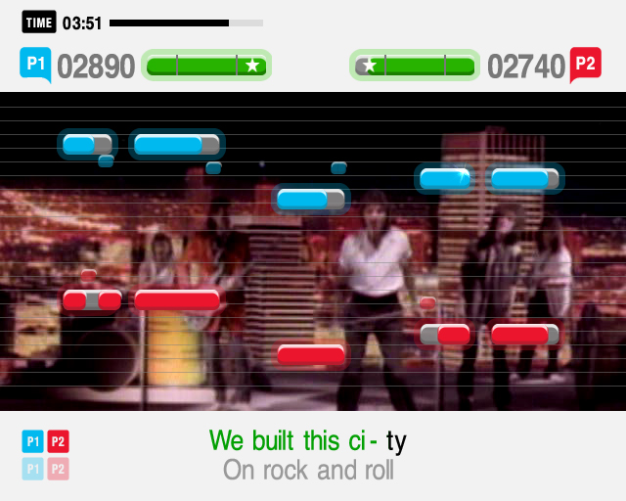

For more information please contact your local PR manager or visit:

www.singstargame.come

www.playstation.com

About Sony Computer Entertainment Europe Ltd.
Sony Computer Entertainment Europe (SCEE), based in London, is responsible for the distribution, marketing and sales of PS one®, PlayStation®2 and PlayStation® Portable software and hardware in 104 territories across Europe, the Middle East, Africa and Oceania. SCEE also develops, publishes, markets and distributes games software for the three formats, and manages the third party licensing programs for these platforms in the PAL territories. At the end of June 2005, over 40 million PlayStation® units had been shipped across these PAL territories, over 102 million worldwide. Between its European debut on 24 November 2000 and 20th July 2005, over 33 million PlayStation®2 units have been shipped across the PAL territories, over 91 million world-wide, making it one of the most successful consumer electronic products in history. Between the launch of the PSP in Japan in December 2005 and 21 July 2005, over 5 million PSPs have been shipped worldwide.

PlayStation and the PlayStation logo, PS one and PS2 are registered trademarks of Sony Computer Entertainment Inc. PSP and UMD (Universal Media Disc) are trademarks of Sony Computer Entertainment Inc. All other trademarks are property of their respective owners.

More information about PlayStation products can be found at http://www.scee.com , www.yourpsp.com and www.playstation.com. or visit the Virtual Press Office at www.scee.presscentre.com.

